Face Off Face Painting by Will Bowman  605 Raleigh Rd Pkwy W, Wilson, NC 27893 www.faceofffacepainting.yolasite.com |  | 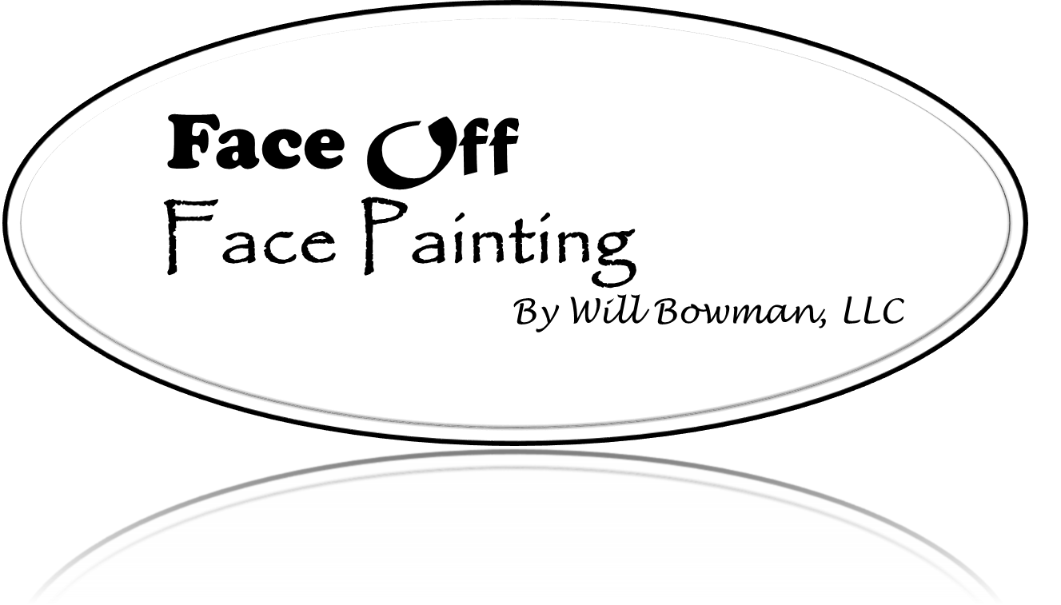
Invoice #__________  Face Painting Invoice and Service Agreement  Date Written: _________  Deposit Received: ________  Date of Event: _________ | Services Performed By: |  | Services Performed For:
 | Face Off Face Painting by Will Bowman  605 Raleigh Rd Pkwy W  Wilson, NC 27893 |  | [Client Address]  [City, ST ZIP Code]

Client Information:
Client Name: ________________________________ How did you hear about us? __________________
Mailing Address: ______________________________________________________________________
Contact Phone: _________________ Cell Phone: __________________ Email: ____________________
Fax #: _____________________ Contact Number Day of Event: ________________________

Event Information:
Event Date: ________ Day of the Week: _____ Indoor or outdoor? _______ Event Start Time: ____ am/pm
Party Location/Address: _______________________________________ Artist Time: _______ to _______
Type of Event: ____________________________ Set Up Area: ___________________________________
Theme: ____________________________________ Dress Code: __________________________________
Parking at Event: _____________________ (Please hold a parking spot close to the event if possible, I will be carrying my own equipment. If permit or passes are required it must be mailed before the day of the event)

Event Attendees Information:
Age range of attendees at event: ________________ Number of Attendees: ___________________
Any Special Face Painting Requests or Color Preferences? ________________________
Fees: This Section to be ﬁlled in by vendor.
Hours needed: _______ Painters needed: ______________ Tent needed [yes/no] ______
$____________ Mileage ___________________________________________________
$____________ Painter _ __________________________________________________
$____________ Tent _____________________________________________________
$____________ Balance due before event date.
Client agrees to pay the full amount due under this contract, even if Client actually uses Artist for less time than contracted for, or if the event is canceled for any reason. However, in case of postponement, Face Off Face Painting by Will Bowman will work with you to accommodate an alternate date although you may not receive your ﬁrst alternate choice based on the Artist’s prior commitments. The balance may be paid with cash, cashier’s check, or company check payable to: William Bowman, and/or Face Off Face Painting by Will Bowman.
- Booking Date: The time slot will not be reserved for Client until the deposit is paid and the agreement is signed. Faxed or emailed signed agreements will hold booking date for ﬁve (5) days to allow mailing time for deposit. If the deposit is not received within ﬁve (5) days of receipt of a signed contract agreement, the contract agreement is null and void. Should Artist be unable to perform its contracted services for any reason whatsoever, Artist will make their best effort to obtain a suitable and equivalent replacement. Should Artist be unable to perform or to ﬁnd such a replacement, the deposit and any amounts paid by the Client under this contract agreement, will be refunded, with the exception of any special supplies purchased for the Client, at the Client’s request, in which case the cost of the special items purchased will be deducted from the amount refunded and the specialty items will be available for the client to pick up from the Artist.
- Overtime: However, only booked times with deposits are guaranteed, additional time on day of event may not be available, although Artist will attempt to accommodate requests for additional paid time. For private parties, we will paint the number of faces that you have requested on the service agreement. However, on the day of the event, we will paint additional faces at a rate of $15 per face.
- Breaks: Artist will be provided with paid 10 minute breaks for every two hours of contracted time.
- Returned Checks: There will be a $30.00 fee for returned checks, plus the amount of the check and all costs involved in enforcing payment of the debt owed.
- Parking: Artist will be provided with parking in the driveway of the home where services will be provided. If the event is at a commercial facility, Artist will be provided a parking spot next to the commercial facility entrance door. Parking near the place services are provided is necessary to enable the Artist to unload equipment. The Client will reimburse Artist for any parking fees incurred while the Artist is providing its contract agreement services to the Client.
- Limitations on Artwork: Artist will not paint on any part of the body that is not legal to expose, or any place he/she does not feel comfortable painting. Artist will not paint any design or wording that is obscene, offensive or deﬁes good taste. Artist may refuse to paint any symbols or other illustrations that are commonly attributed to “gang” or other illegal group afﬁliations. Artist will not paint copyrighted characters or any designs Artist is not comfortable painting.
- Extreme Adverse Working Conditions: Artist has the right to cease painting and leave without refunding any monies if there are extreme adverse working conditions and the Client fails to remedy the situation after it has been brought to the Client’s attention. Adverse conditions included but not limited to: destructive, violent, or extreme; inappropriate behavior of a child or adult; illegal activities; dangerous weather or work environment conditions; dangerous conditions in general. Our company will not cancel but we will agree to a rain date if discussed TWO days before day of event.
- Liability Statement: Artist is not liable for any parties’ allergic reactions to paints. Only FDA compliant paints and cosmetic grade glitters are used for face painting. Children with skin allergies or sensitive skin should either not participate, or have Artist perform a patch test at the beginning of the party. For safety reasons, Artist will not paint children under 2 years old. For sanitary reasons, Artist will not paint anyone who is or appears to be sick or suffering from: cold sores; conjunctivitis; any infectious skin condition; eczema or open wounds. Artist will use reasonable care, but is not responsible for damage to anyone’s personal health, clothing or property.
- Artist will not supervise children. The behavior and safety of all children and adults is the Parents’ responsibility, and not the Artist’s. Artist cannot see other children and what they are doing while he/she is painting.
- Artist agrees to provide services of general face painting using only FDA compliant products on said contract agreement dates, with acceptance and timely payment of 50% deposit. Artist also agrees that a liability insurance policy is in full force and effect and will provide a current insurance certiﬁcate upon request. For any reason, should Face Off Face Painting by Will Bowman be unable to accommodate your paid booking, or provide a suitable and comparable replacement, a full refund of your deposit will be returned to you or you may receive your next event for the equal amount of time, provided you and the Artist can agree on an available day and time period for the next event and the next event is to occur within a reasonable period of time. In the event that Artist is unable to perform or provide a suitable replacement, Client agrees that a full refund of any amounts paid to Artist will represent a full satisfaction of any and all amounts due from Artist and a demand for the full amount paid to Artist the Client’s full recourse for any and all claims by Client. This means that the Artist is liable to Client for no further claim of damages or other claims of any kind whatsoever, beyond a full refund of any amounts paid by Client to Artist.
- Client agrees to pay the full amount of booked time of face painting services. The client will be responsible for any fees or expenses, including attorney’s fees, incurred in connection with collecting delinquent amounts owed to Face Off Face Painting by Will Bowman under this Agreement. To provide sheltered area in event of rain. To provide shaded area in extreme heat. Client and all guest who have their faces painted agrees to defend, indemnify, and hold harmless Face Off Face Painting by Will Bowman and/or any of its artists from liability and claim for damages due to bodily injury, death, property damage, sickness, illness, disease, or expenses or losses from Face Off Face Painting by Will Bowman’s performance/s.

Face Off Face Painting by Will Bowman looks forward to making your event special and memorable. We encourage you to contact Face Off Face Painting by Will Bowman if you have any question or concerns. We will work with you as best we can to accommodate your requests to ensure the participants have a fun and colorful time! I have read, understand and accept the above Liability Statement, and the conditions of this agreement. I accept the details of this agreement as accurate.

Client Signature _________________________________ Date ______________________
Face Off Face Painting by Will Bowman _______________________ Date__________________

To book your date and time, please mail the signed contract and 50% deposit to:
Face Off Face Painting by Will Bowman
605 Raleigh Rd Pkwy W
Wilson, NC 27893

The requested date will be held for (5) ﬁve business days, allowing time for mailing. If the contract and deposit is not receive within (5) ﬁve business days, the date and time will be released to be booked by another event.

Comments:
______________________________________________________________________________
______________________________________________________________________________
______________________________________________________________________________
______________________________________________________________________________
______________________________________________________________________________
______________________________________________________________________________

